Development Environment and Tools
Tool | Version
Visual Studio | Visual Studio 2026
Project Template | ASP.NET Core Web App (Model-View-Controller)
Framework | .NET 10.0 (Long Term Support)
.NET SDK | 10.0.203
SQL Server Management Studio | 22.6.0
SQL Server Instance | .\SQLEXPRESS01
SQL Server Version | 13.0.5026
Version Control | GitHub Desktop
Database Name: CityHospitalDB
SQL Server Instance: .\SQLEXPRESS01
Database Tool: SQL Server Management Studio 22.6.0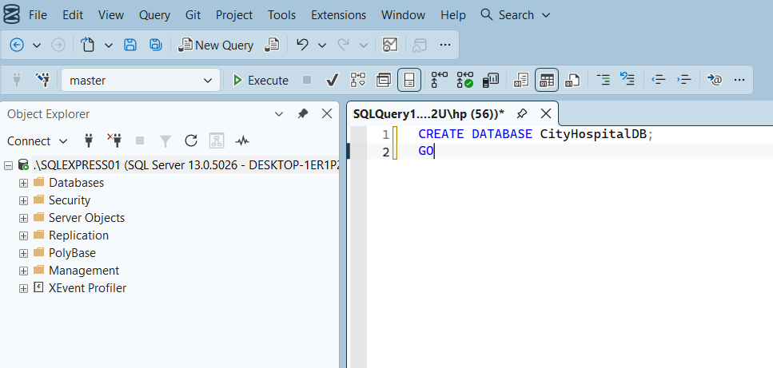
The system contains six main tables:
Patients table stores patient personal information, contact details and medical history.
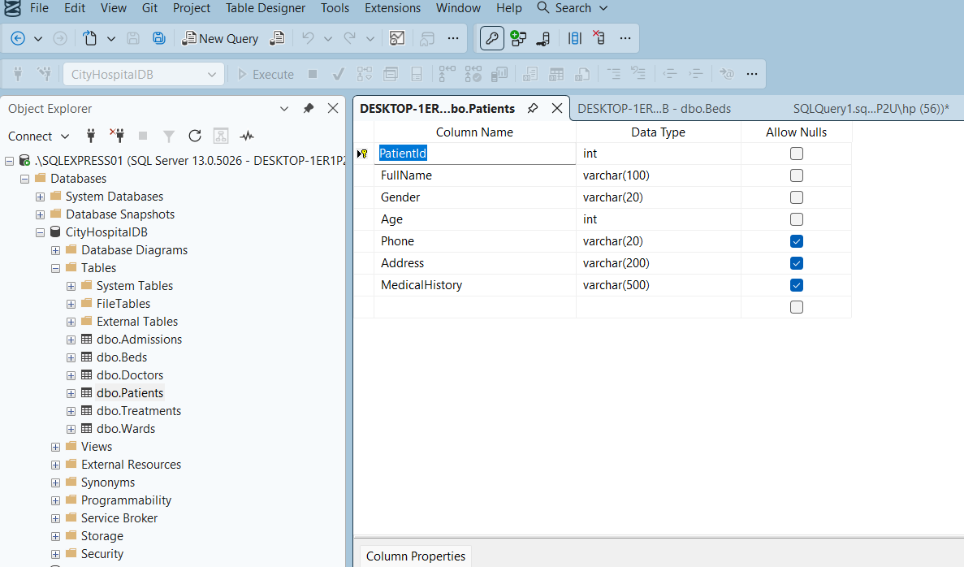
Doctors table stores doctor name, specialization, assigned ward, availability status and consultation schedule.
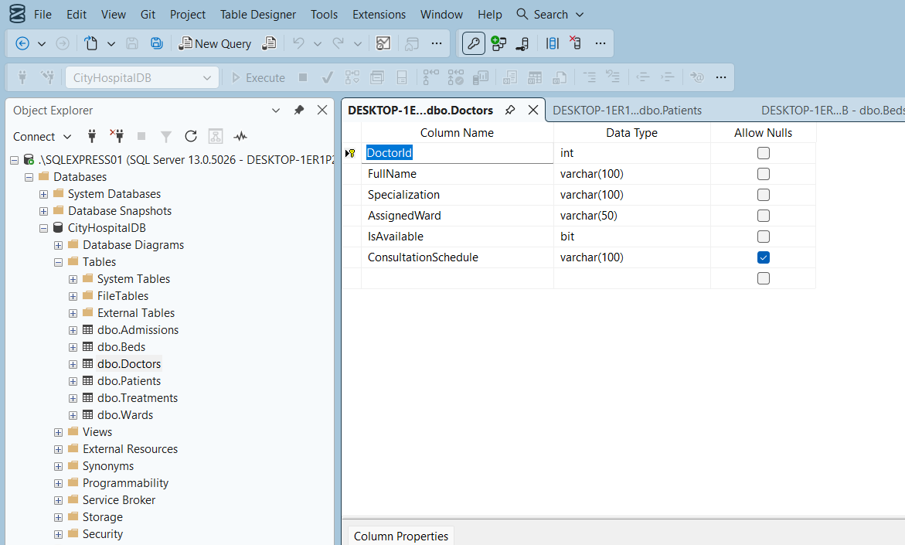
Wards table stores the four hospital wards: General, ICU, Maternity and Pediatric.
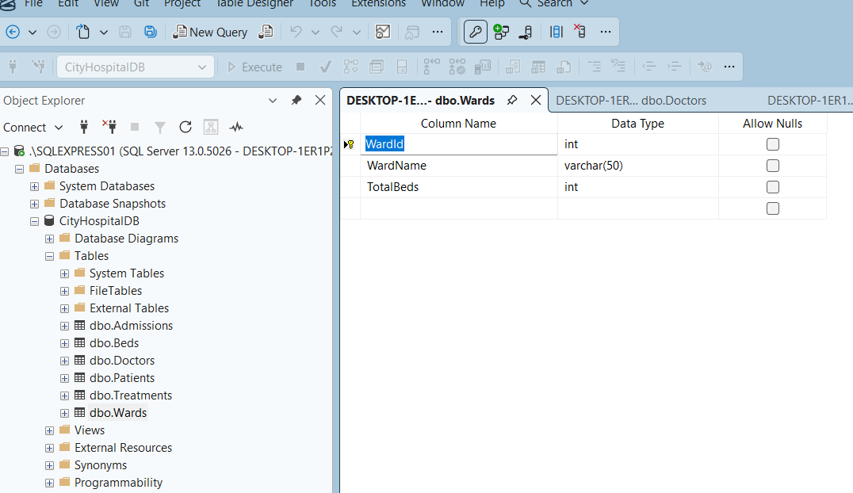
Beds table stores bed numbers and their assigned ward. It also contains an occupancy status to show whether a bed is available or occupied.
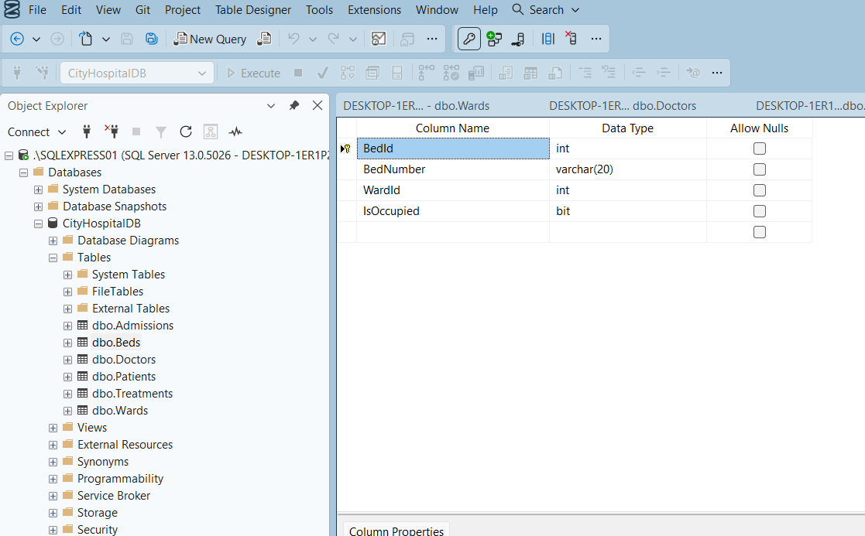
Admissions table connects patients, doctors, wards and beds. It stores admission type, admission date, discharge date and current admission status.
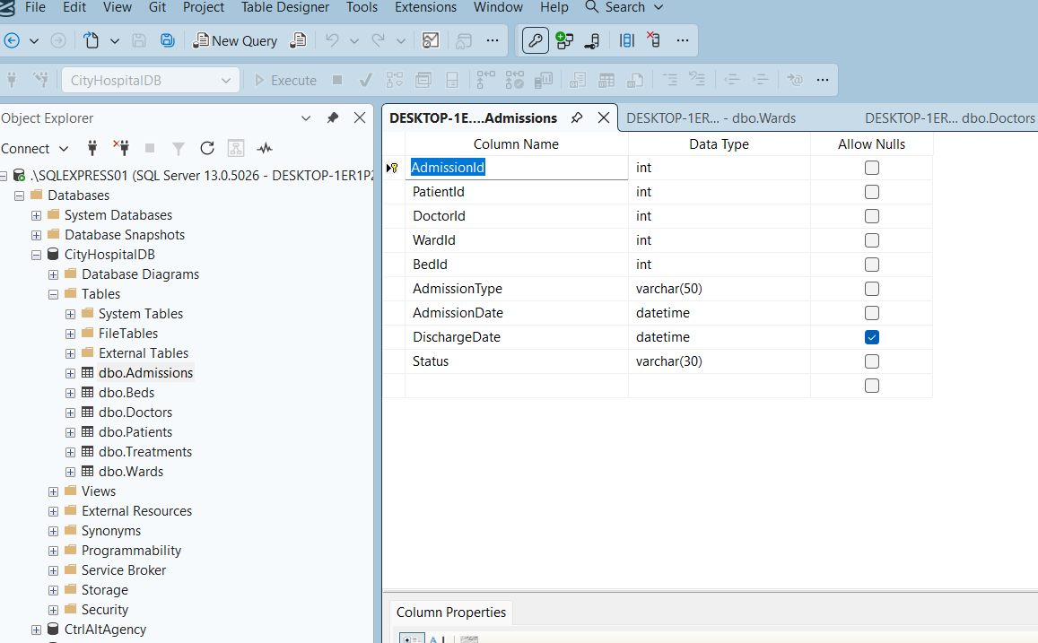
Treatments table stores treatment details given to admitted patients during their stay.
